**Front End Engineering-II**

Project Report

Semester-IV (Batch-2022)

E-Commerce Website



**Supervised By: Submitted By:**

Ms. Preenu Mittan Bhuvesh Mittal

2210991450 (G-18)

**Department of Computer Science and Engineering**

**Chitkara University Institute of Engineering & Technology, Chitkara University, Punjab**

**Abstract**

The rapid growth of E-commerce has transformed the retail landscape, reshaping how consumers shop and interact with products and services online. This abstract encapsulates the essence and objectives of a frontend development project focused on enhancing user experience in E-commerce through an intuitive and feature-rich website.

The project aims to address the following key objectives:

1. **User Account Management**: The website enables users to create accounts, facilitating personalized experiences and streamlined checkout processes. Account management features include registration, login, password recovery, and profile editing functionalities.
2. **Seamless Cart Management**: A robust cart management system is implemented, allowing users to add items to their carts, modify quantities, and remove items as needed. The cart interface provides real-time updates on the total price and item count, enhancing transparency and convenience during the shopping process.
3. **Intuitive Navigation and Search**: The website features an intuitive navigation structure, enabling users to explore product categories and subcategories effortlessly. A powerful search functionality is integrated, allowing users to quickly find specific products based on keywords, categories, or attributes.
4. **User Feedback and Interaction**: Interactive elements such as product ratings, reviews, and recommendations are incorporated to encourage user engagement and facilitate informed purchasing decisions. User feedback mechanisms empower customers to share their experiences and insights, fostering a sense of community and trust.
5. **Accessibility and Performance**: The website prioritizes accessibility standards, ensuring compliance with web accessibility guidelines to accommodate users with diverse needs and disabilities. Performance optimization techniques are implemented to minimize loading times and deliver a seamless browsing experience.

In summary, the frontend development project aims to elevate the E-commerce experience by prioritizing user-centric design, functionality, and accessibility. Through iterative design iterations and user testing, the website endeavors to become a preferred destination for online shoppers, providing a seamless and engaging platform for discovering and purchasing products and services.

**Index**

|  |  |  |
| --- | --- | --- |
| **S.no** | **Topics** | **Page No.** |
| **1.** | **Introduction** | **4** |
| **2.** | **Objectives** | **5** |
| **3.** | **Significance** | **6** |
| **4.** | **Scope** | **7** |
| **5.** | **Problem Statement** | **8** |
| **6.** | **Methodology** | **10** |
| **7.** | **Code Snippets** | **12** |
| **8.** | **Results** | **25** |
| **9.** | **References** | **30** |

**Introduction:**

In the contemporary digital landscape, electronic commerce, or e-commerce, stands as a cornerstone of modern business operations. The proliferation of internet connectivity and the evolution of user behaviours have catalysed the exponential growth of online shopping platforms. At the heart of this digital transformation lies the front-end development, where user interfaces are crafted to provide seamless and engaging experiences for customers.

This project report delves into the intricacies of front-end development within the realm of e-commerce, with a particular focus on the implementation of essential features: a fully functional cart, a dynamic search bar, and an intuitive login page. These features serve as the bedrock of user interaction within an e-commerce platform, facilitating navigation, exploration, and transactional activities.

The implementation of a fully functional cart system represents a critical component of any e-commerce website. Through meticulous design and development, the cart feature enables users to add, remove, and modify items in their shopping cart seamlessly. By integrating dynamic updates and intuitive user interactions, the cart system enhances the overall shopping experience, streamlining the checkout process and fostering customer satisfaction.

Additionally, the inclusion of a dynamic search bar empowers users to swiftly discover products of interest amidst the vast inventory of an e-commerce website. Leveraging advanced search algorithms and user-centric design principles, the search bar functionality enhances discoverability and navigation, enabling users to find relevant products with minimal effort.

Furthermore, the implementation of a user-friendly login page serves as a gateway to personalized shopping experiences and enhanced security measures. By providing users with secure authentication mechanisms and streamlined login processes, the login page fosters trust and confidence among users, encouraging repeat visits and driving customer retention.

Through meticulous attention to detail and adherence to modern front-end development practices, the cart, search bar, and login page functionalities converge to create a cohesive and immersive e-commerce experience. By prioritizing usability, performance, and accessibility, developers can empower businesses to thrive in the dynamic landscape of online commerce.

This project report aims to provide a comprehensive overview of the design, development, and implementation of these essential front-end features within the context of e-commerce websites.

**Objectives:**

The primary objective of this project is to conceptualize, design, and develop a user-centric E-commerce website that encapsulates the ethos of modern online retailing while addressing the evolving needs and preferences of consumers. The project encompasses the following specific objectives:

* To create an intuitive and visually appealing user interface that enhances user engagement and facilitates seamless navigation.
* To implement robust account management features, including user registration, login, and profile editing functionalities, to personalize the user experience.
* To integrate a comprehensive cart management system that enables users to add, remove, and modify items in their carts, thereby streamlining the checkout process.
* To incorporate advanced search and filtering functionalities that empower users to discover products based on their preferences, categories, and attributes.
* To optimize the website for responsiveness, accessibility, and performance across various devices and screen sizes, ensuring a consistent and enjoyable user experience.
* To leverage user feedback mechanisms, such as product ratings, reviews, and recommendations, to foster community engagement and trust.

**Significance:**

The significance of this project lies in its potential to redefine the E-commerce landscape by delivering a user-centric, feature-rich platform that transcends conventional boundaries and sets new standards for online retailing. By amalgamating cutting-edge technology, design principles, and consumer insights, the project endeavours to:

* Enhance the overall user experience and satisfaction, thereby increasing customer retention and loyalty.
* Foster brand differentiation and competitive advantage in a crowded marketplace.
* Drive sales and revenue growth through personalized recommendations, streamlined checkout processes, and intuitive navigation.
* Establish a strong foundation for future scalability, innovation, and expansion in response to evolving market dynamics and consumer preferences.

In essence, the project represents a concerted effort to harness the transformative potential of E-commerce to create value for stakeholders, empower consumers, and shape the future of digital commerce.

**Scope:**

The scope of the project encompasses the conceptualization, design, development, testing, and deployment of a frontend E-commerce website prototype. While the project primarily focuses on frontend aspects, including user interface design, navigation, and user experience enhancements, it may also involve integration with backend systems and third-party services to enable core functionalities such as account management, cart management, and search capabilities.

The project will adhere to established best practices, standards, and guidelines in web development and user interface design, with an emphasis on responsiveness, accessibility, and performance optimization. Additionally, the project may involve user research, usability testing, and iterative design iterations to gather feedback and iterate on the prototype's design and functionality.

Overall, the project seeks to deliver a tangible and demonstrable prototype that showcases the envisioned E-commerce experience and sets the stage for future enhancements, iterations, and scalability.

**Problem Statement:**

In the landscape of modern e-commerce, the success of an online store hinges significantly on the effectiveness and efficiency of its front-end components. While creating a fully functional cart, search bar, and login page marks essential milestones in the development of an e-commerce website, several challenges and considerations persist that warrant attention and resolution.

1. **User Experience Optimization:**
   1. Ensure that the cart, search bar, and login page are seamlessly integrated into the website's overall user interface, providing intuitive navigation and effortless interaction.
   2. Address usability issues such as responsiveness across devices, accessibility for users with disabilities, and intuitive design for users of varying technical proficiency.
2. **Performance and Scalability:**
   1. Develop front-end components that prioritize performance optimization to minimize loading times and enhance user satisfaction.
   2. Implement scalable solutions to accommodate increasing user traffic and data processing demands without compromising website performance.
3. **Security and Authentication:**
   1. Implement robust authentication mechanisms for the login page to safeguard user credentials and prevent unauthorized access.
   2. Employ encryption techniques and secure protocols to protect sensitive information exchanged during the login process.
4. **Search Functionality and Navigation:**
   1. Enhance the search bar functionality to deliver relevant and accurate search results, including product suggestions, filtering options, and advanced search capabilities.
   2. Optimize navigation within the website by integrating intuitive search filters, category browsing, and breadcrumb trails to guide users effectively.
5. **Cart Management and Checkout Process:**
   1. Ensure seamless integration between the cart functionality and product pages, allowing users to add, update, and remove items effortlessly.
   2. Streamline the checkout process by implementing user-friendly forms, address validation, and secure payment gateways to facilitate smooth transactions.

By addressing these challenges and considerations, the development of fully functional cart, search bar, and login page within an e-commerce website can contribute significantly to enhancing user engagement, driving conversions, and fostering customer satisfaction in the digital marketplace.

**Methodology:**

The development methodology chosen for the front-end development of the e-commerce website encompasses a structured approach aimed at ensuring efficiency, collaboration, and the delivery of high-quality front-end components. The proposed methodology consists of the following key stages:

1. **Requirement Analysis:**
   1. Conduct thorough discussions with stakeholders to gather requirements, understand business objectives, and define user needs.
   2. Identify key features and functionalities required for the cart, search bar, and login page, considering usability, accessibility, and performance requirements.
   3. Create user stories, wireframes, and mock-ups to visualize the user interface and establish a clear understanding of design expectations.
2. **Design Phase:**
   1. Translate the requirements and design concepts into actionable design specifications and guidelines.
   2. Design the user interface for the cart, search bar, and login page, focusing on intuitive navigation, visual appeal.
   3. Iterate on design prototypes based on feedback from stakeholders and usability testing to refine the user experience.
3. **Development:**
   1. Adopt a component-based development approach, breaking down the front-end components into modular and reusable units.
   2. Write clean, well-structured HTML, CSS, and JavaScript code adhering to industry best practices and coding standards.
4. **Testing:**
   1. Conduct comprehensive testing of the front-end components to ensure functionality, performance, and cross-browser compatibility.
   2. Perform unit tests, integration tests, and end-to-end tests to validate individual components and their interactions.
   3. Seek feedback from stakeholders and end-users through usability testing to identify areas for improvement and refinement.
5. **Deployment and Optimization:**
   1. Deploy the front-end components to staging or production environments, ensuring seamless integration with the backend system.
   2. Monitor performance metrics such as page load times, responsiveness, and user interactions using web analytics tools.
   3. Optimize front-end assets, including images, scripts, and stylesheets, to minimize load times and improve overall performance.
   4. Continuously monitor and iterate on the front-end components based on user feedback, changing requirements, and emerging technologies.

**Code Snippet:**

1. **Header**

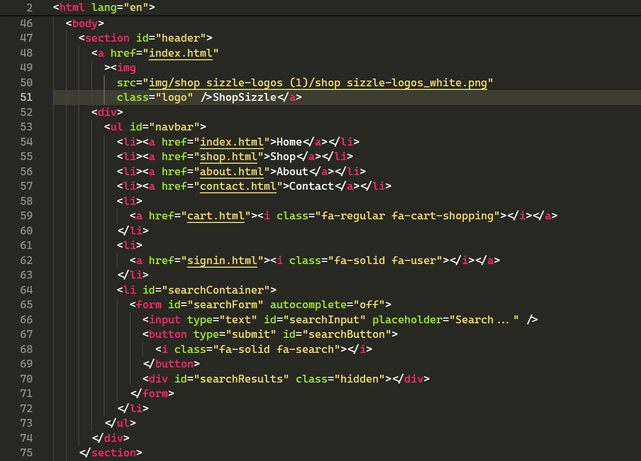

1. **Footer**

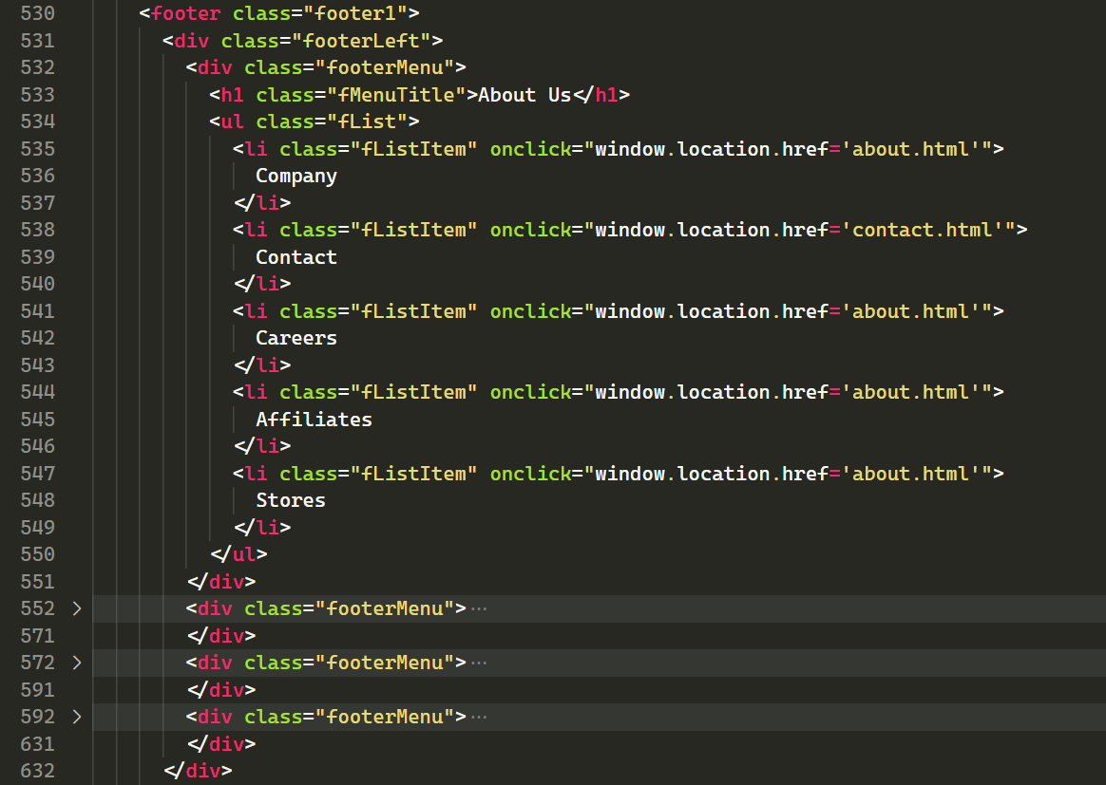

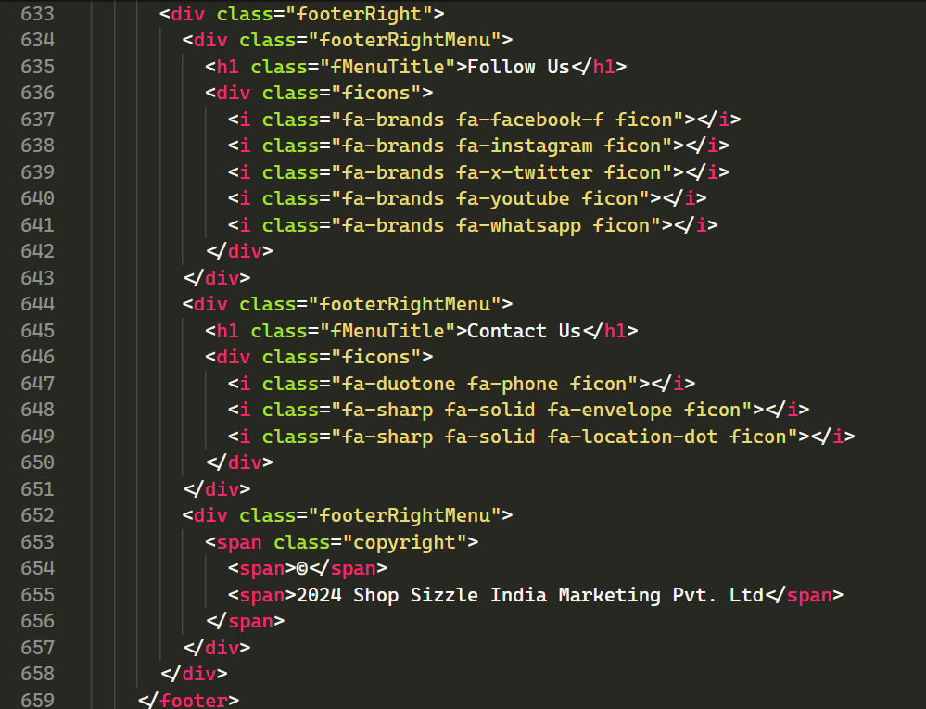

1. **Home Page**

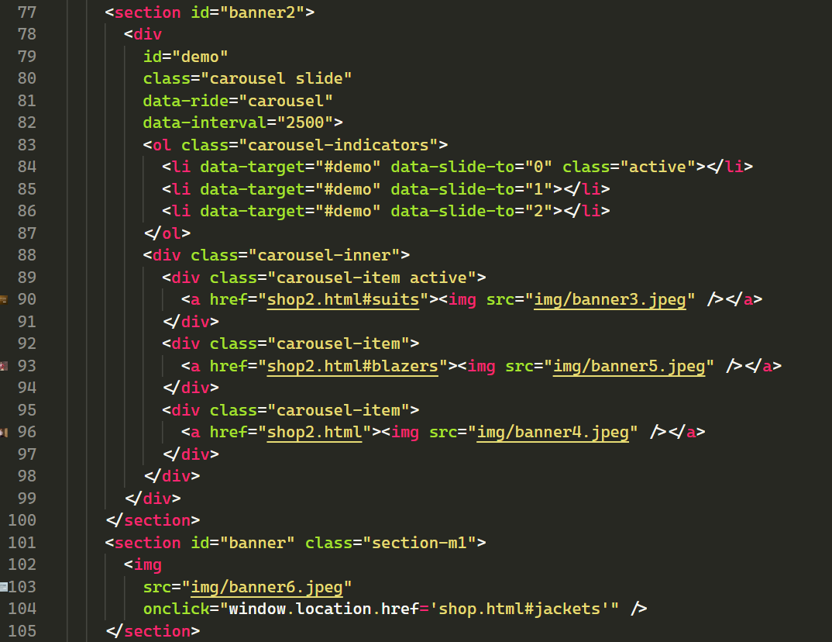

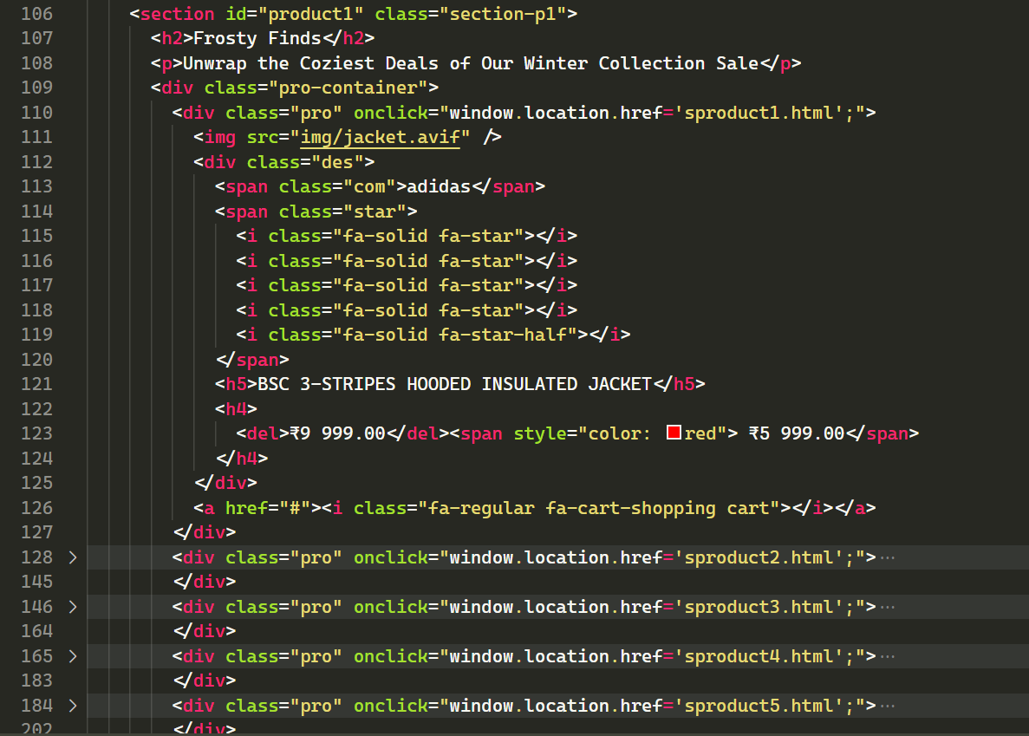

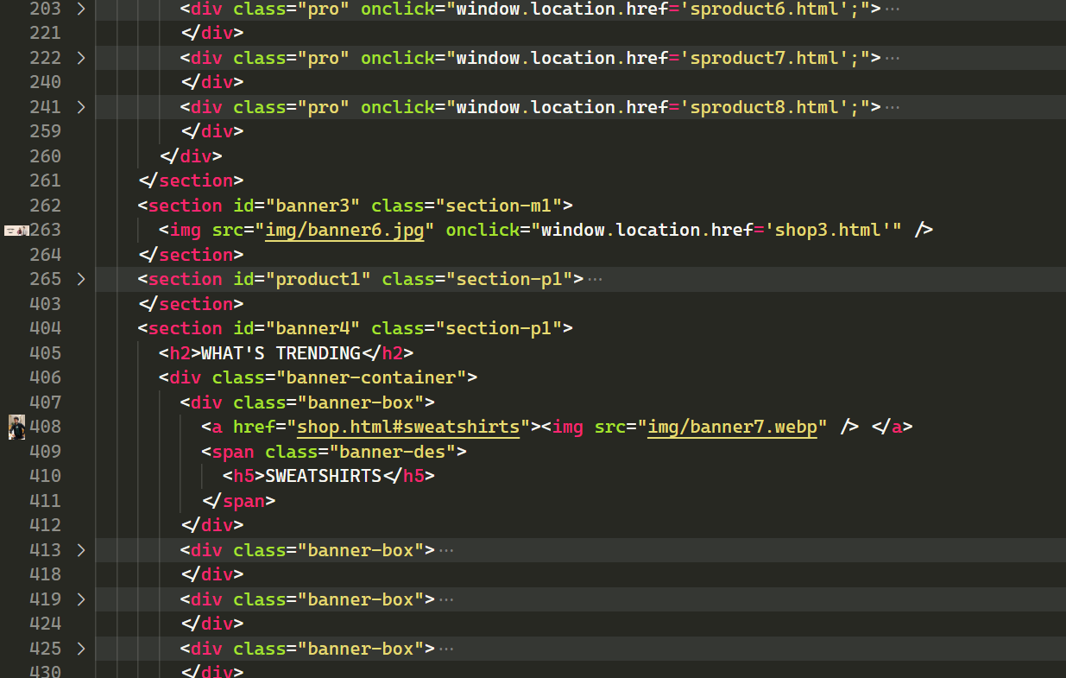

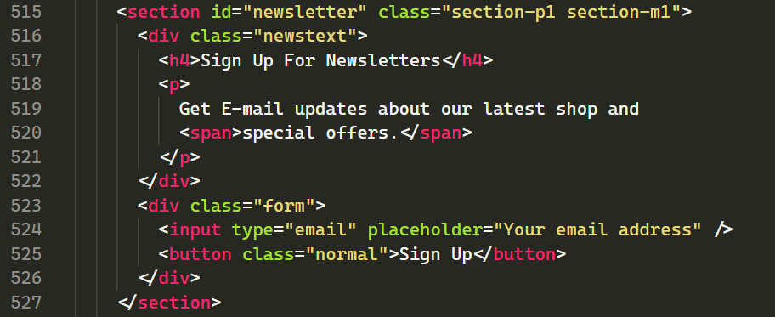

1. **Shop Page:**

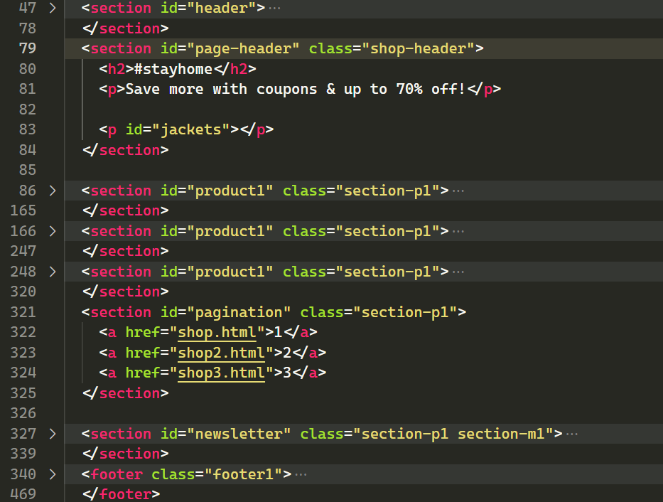

1. **About Page:**

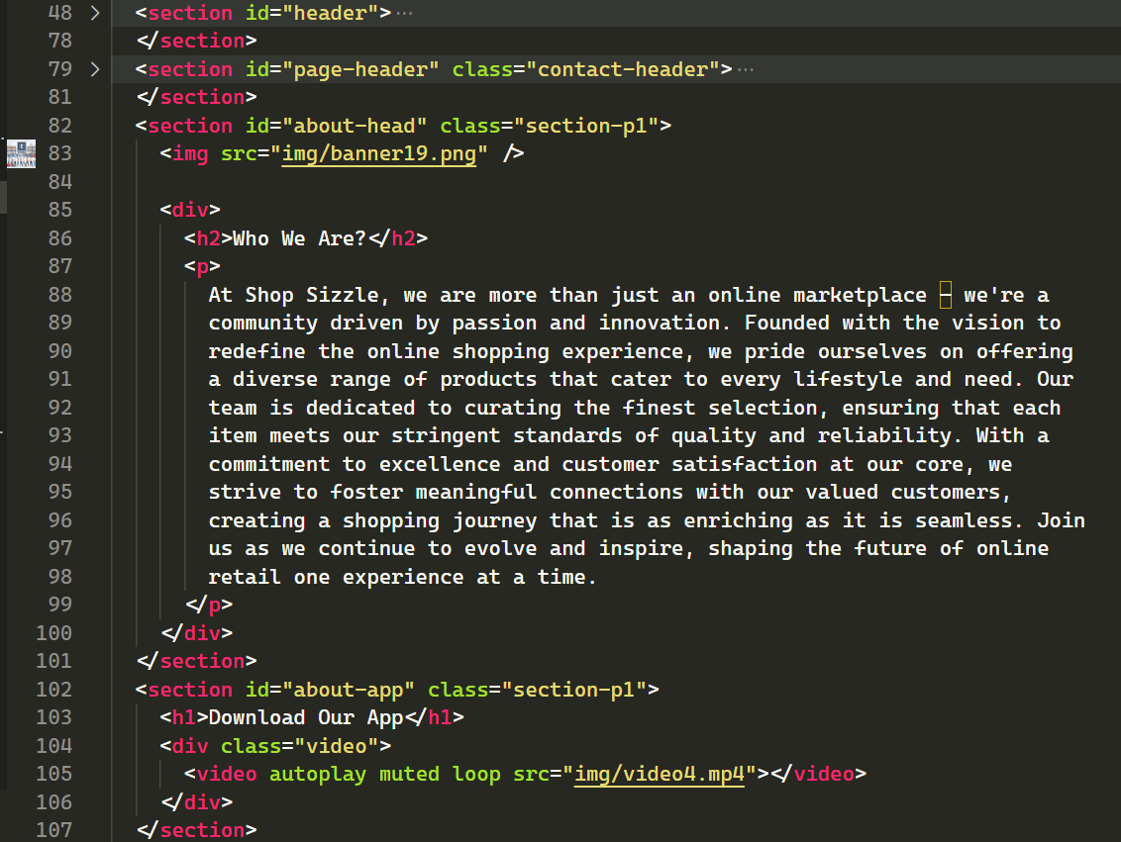

1. **Contact Us Page:**

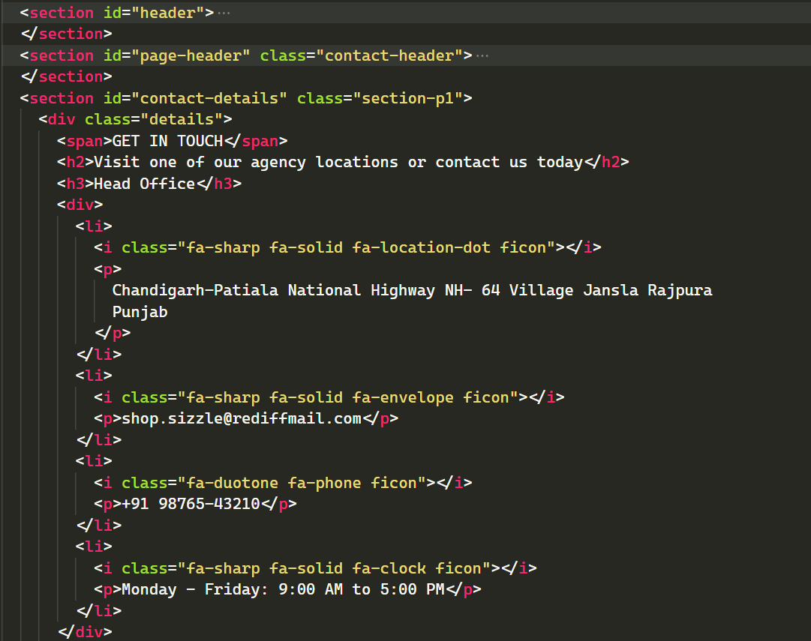

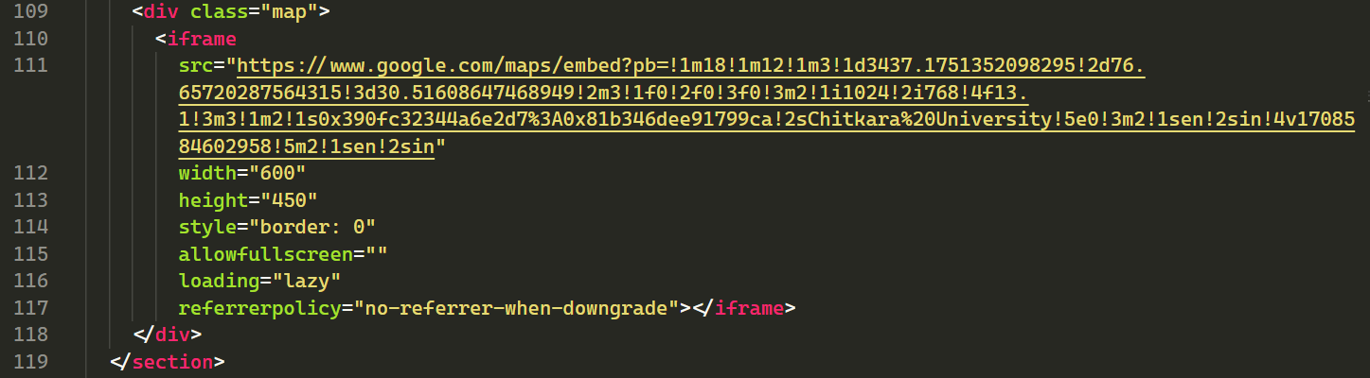

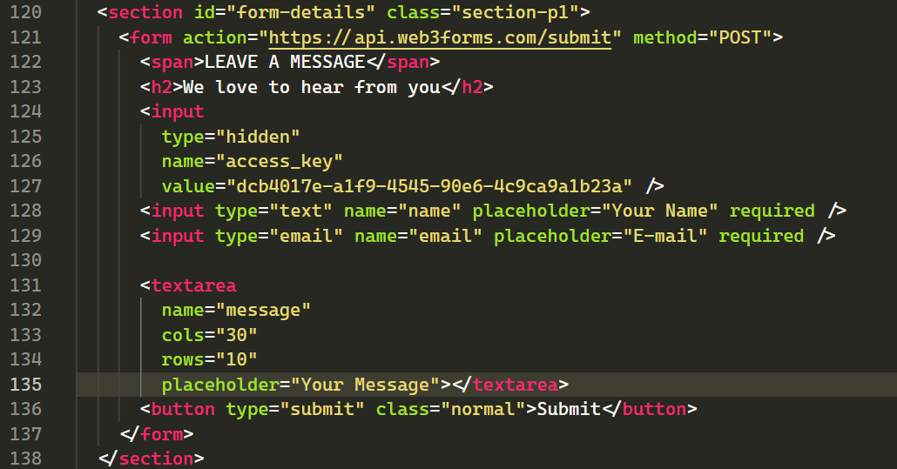

1. **Cart Page:**

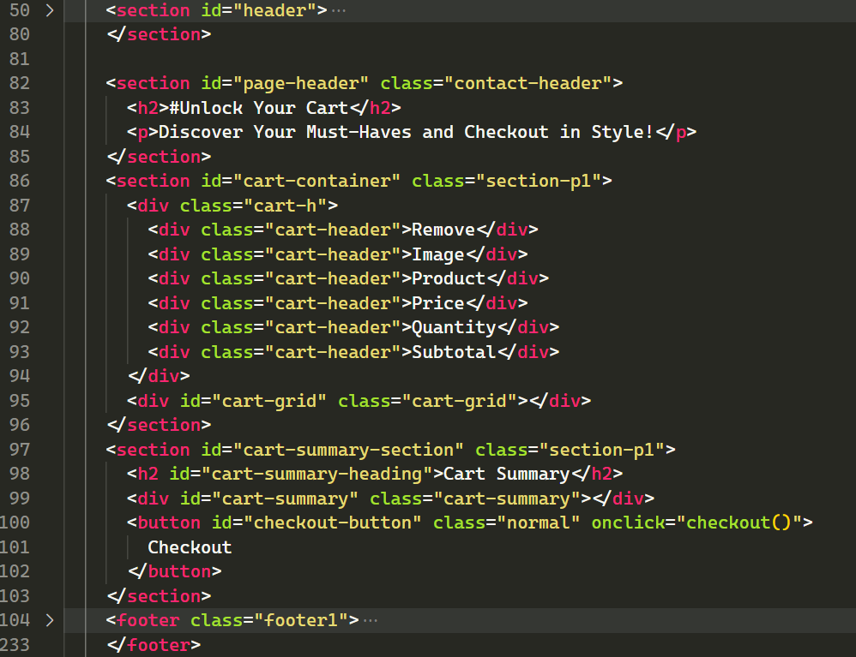

1. **Login Page:**

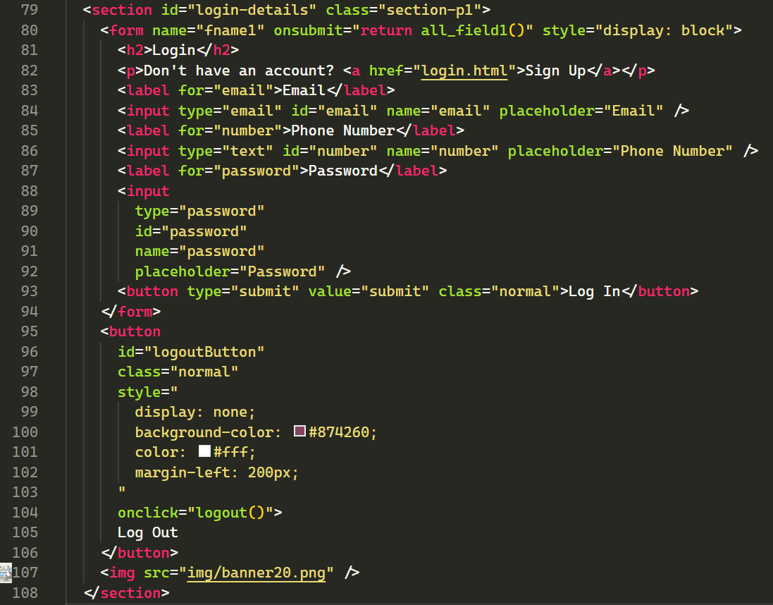

1. **Sign Up Page:**

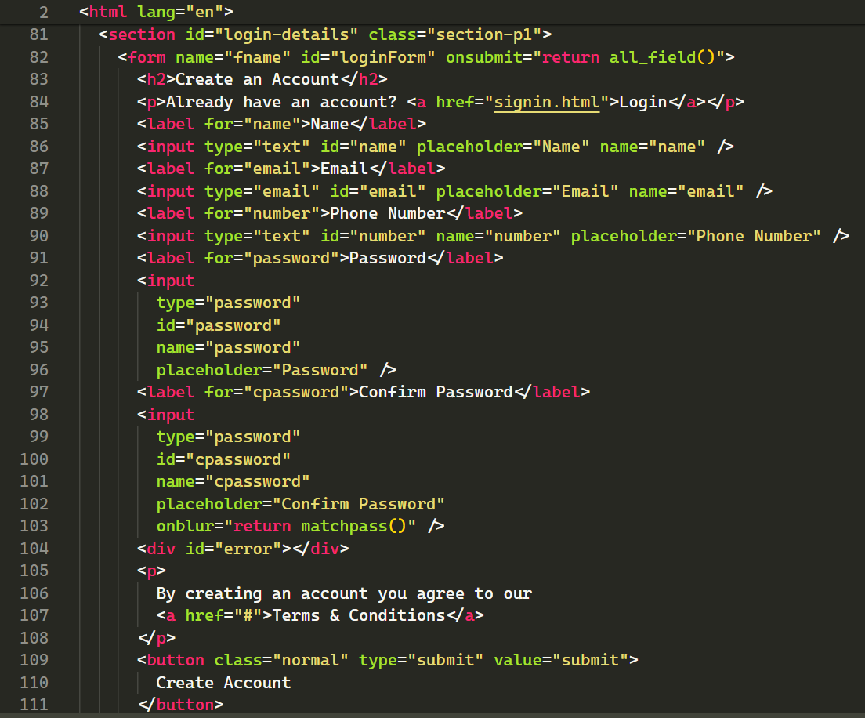

1. **Product Page:**

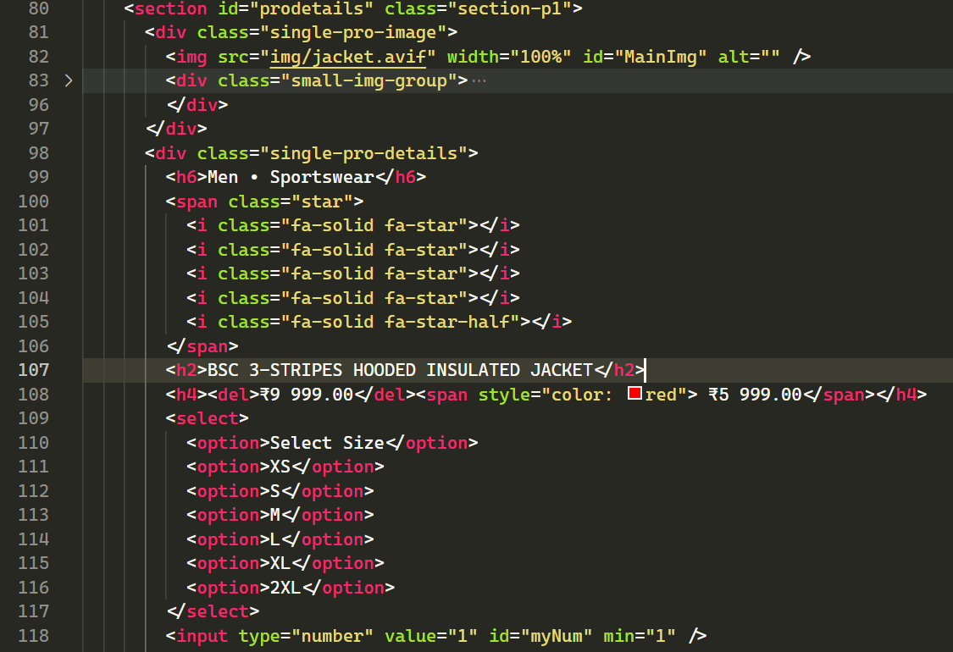

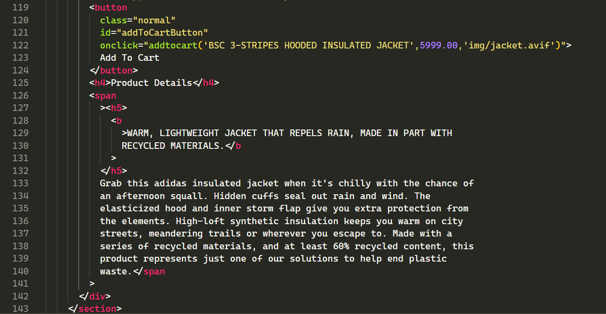

1. **JavaScript Files:**

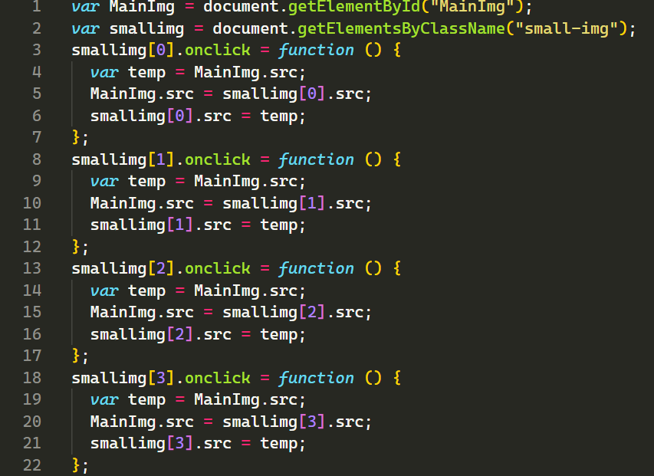

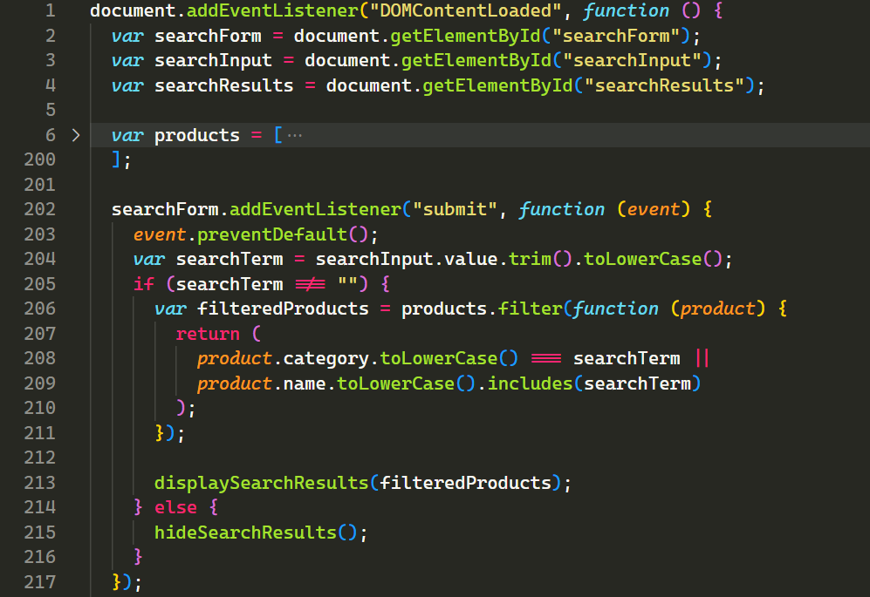

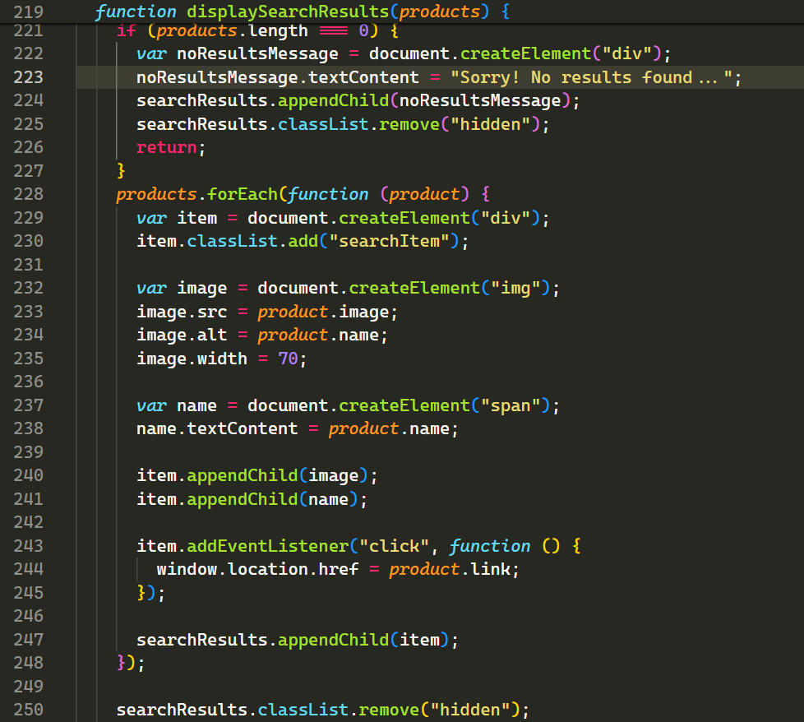

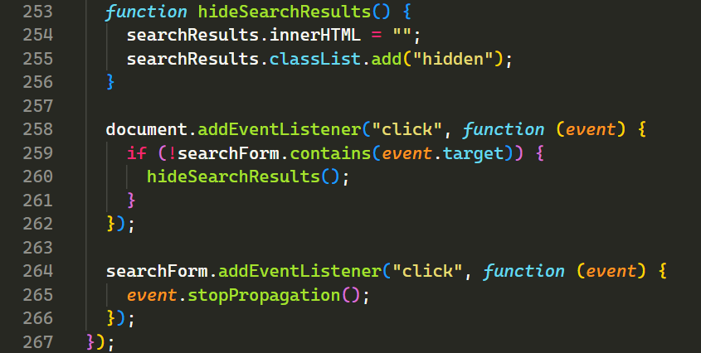

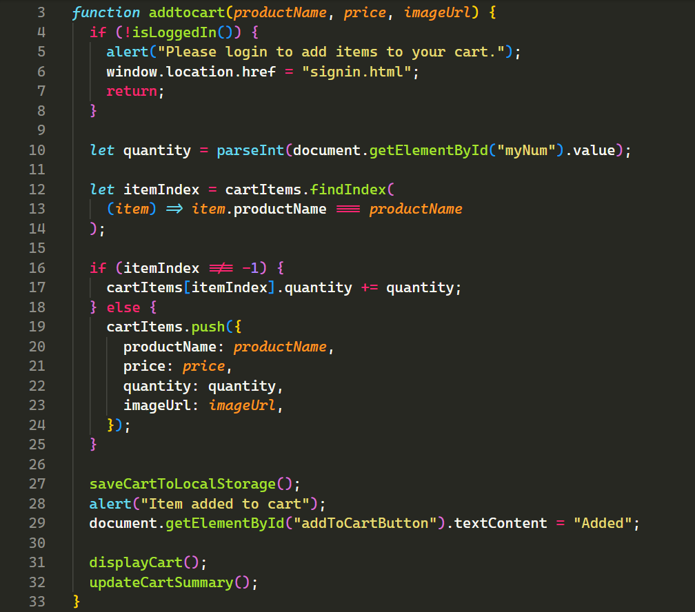

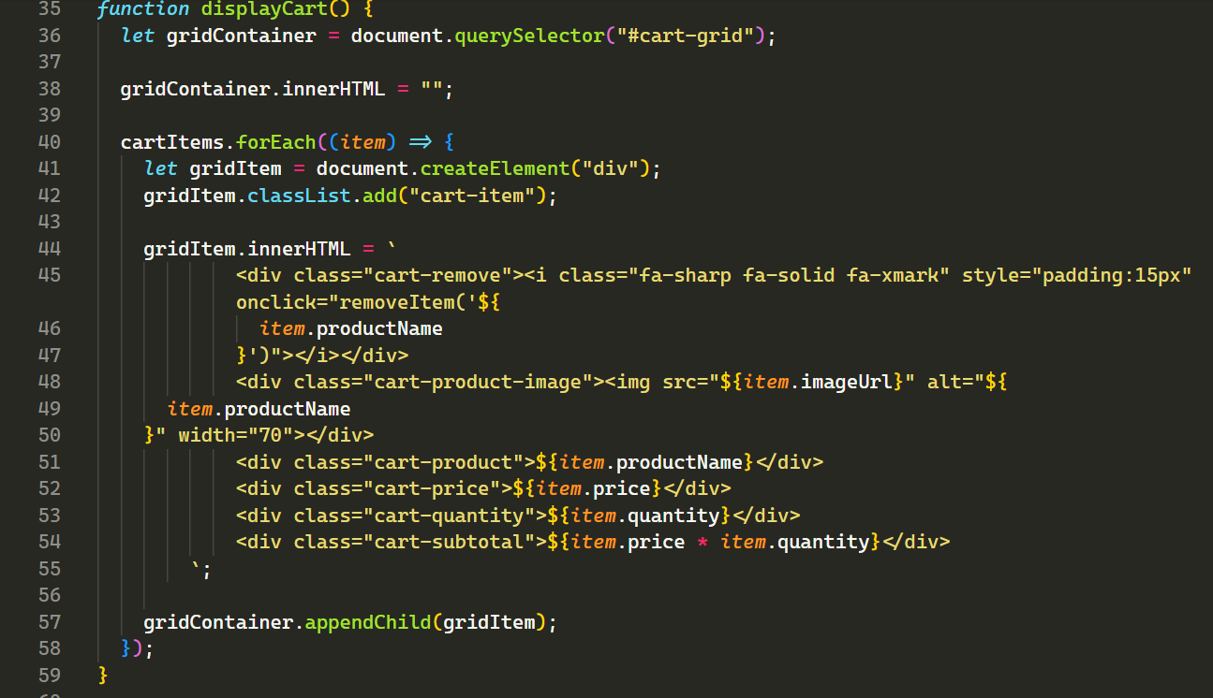

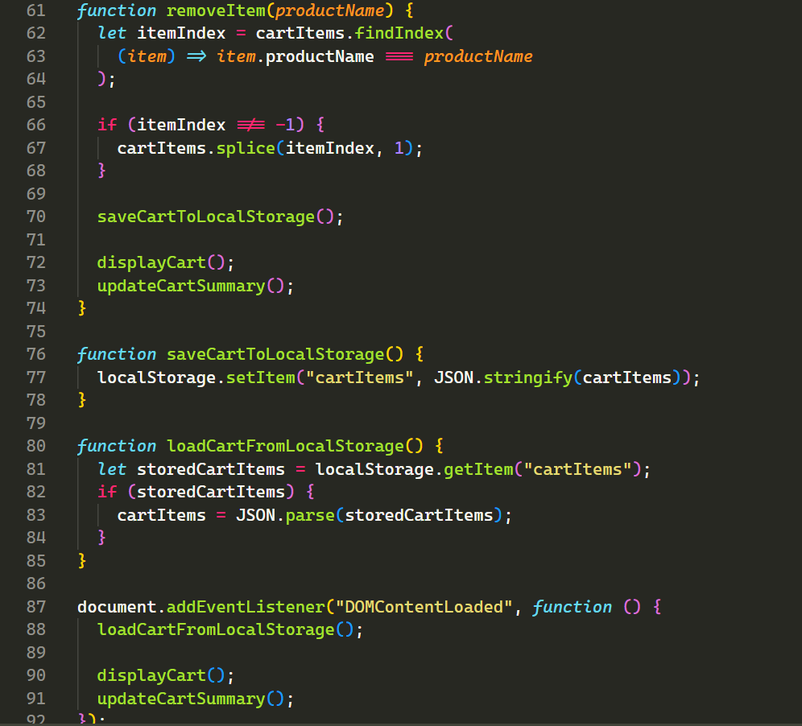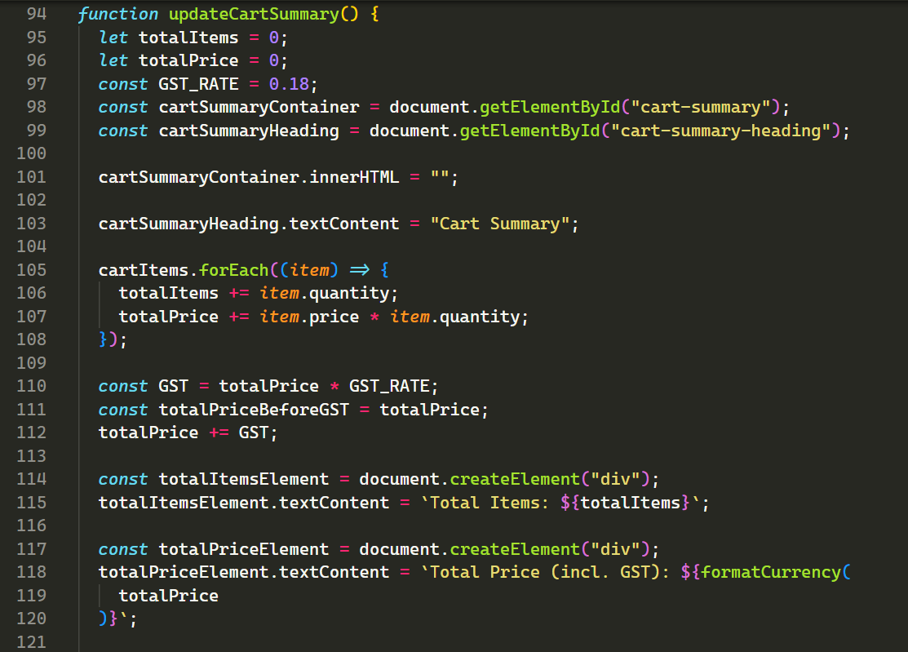

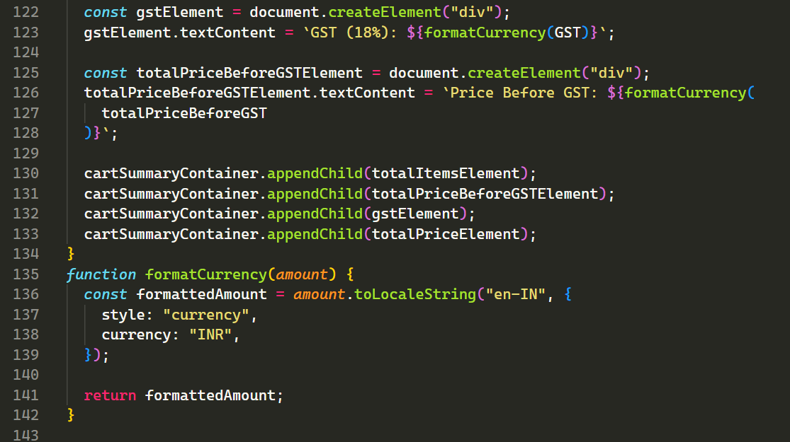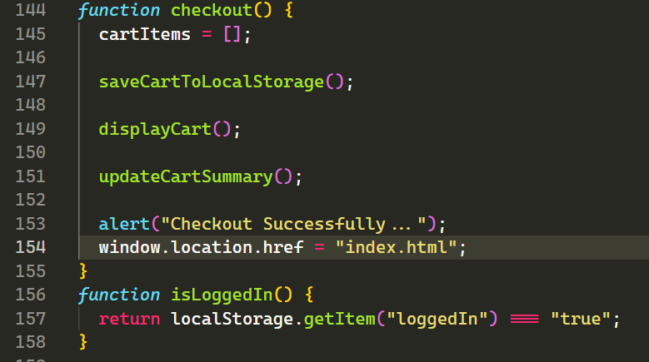

**Results:**



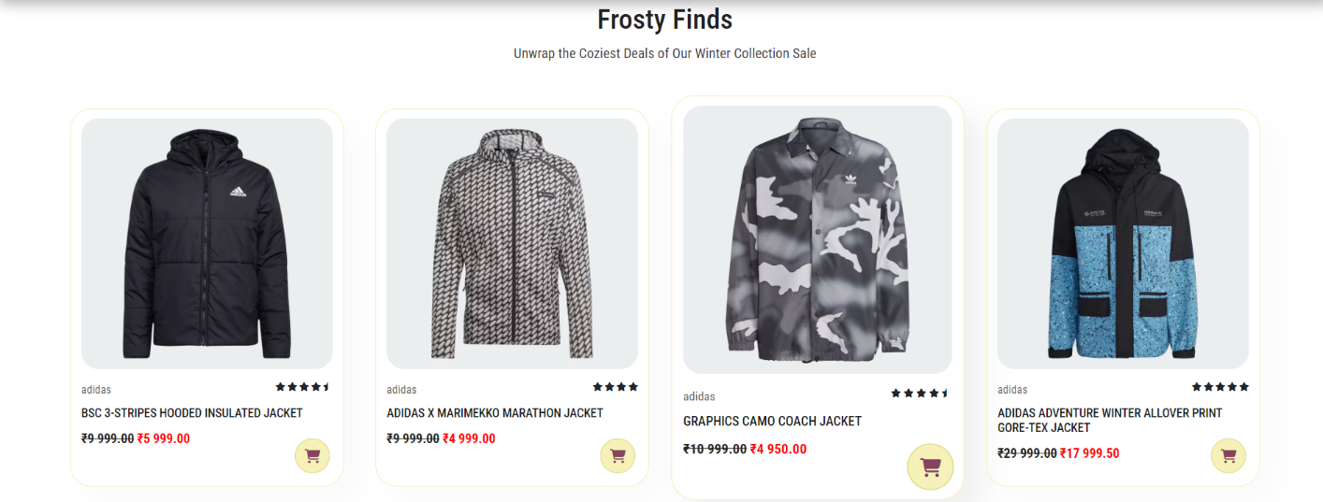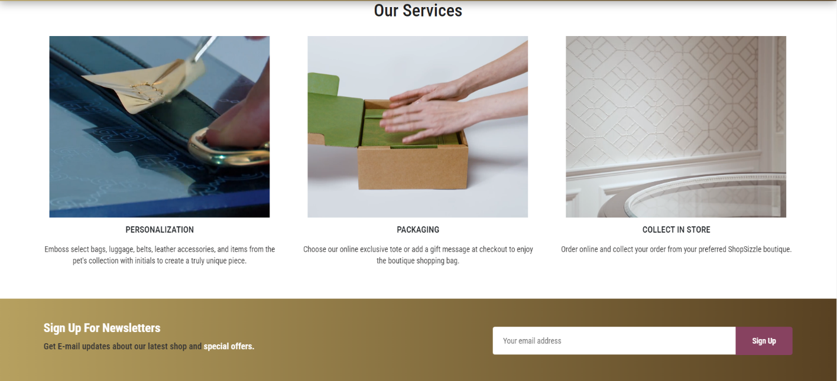

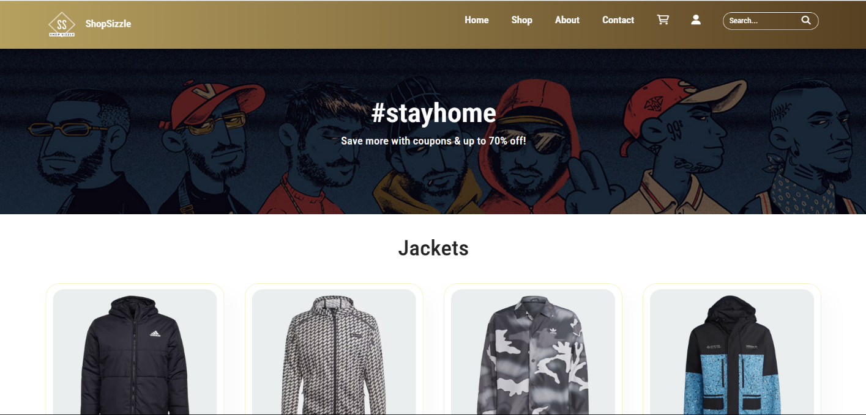

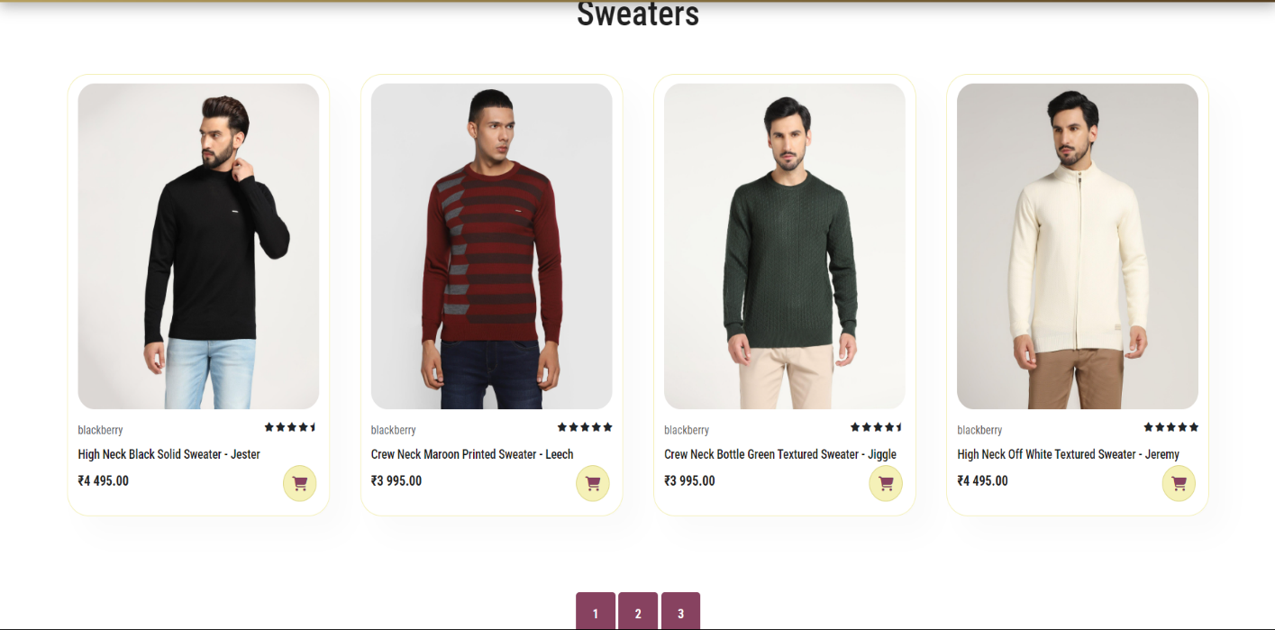

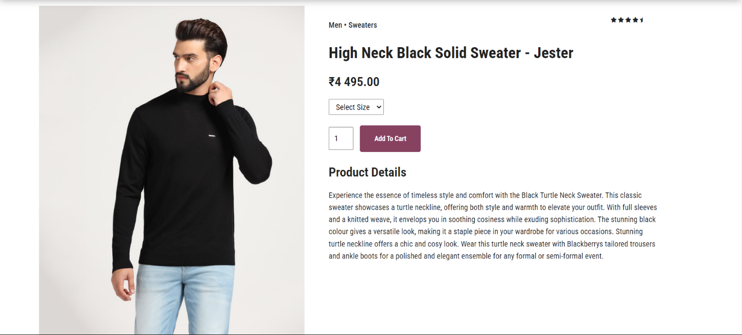

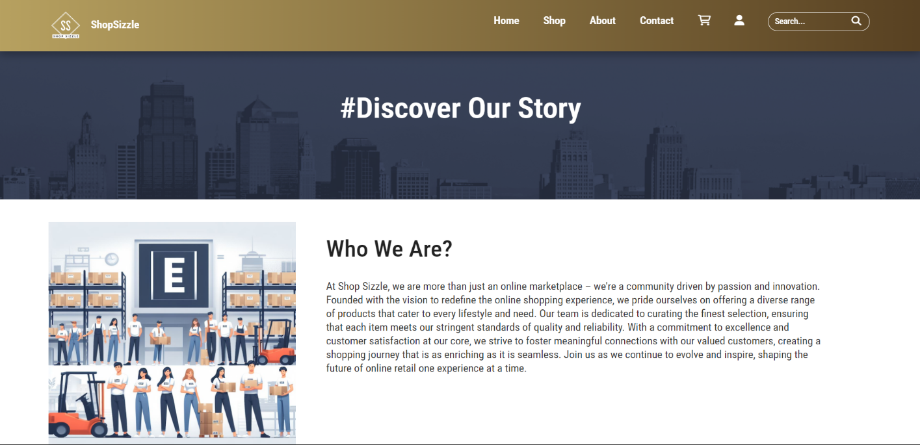

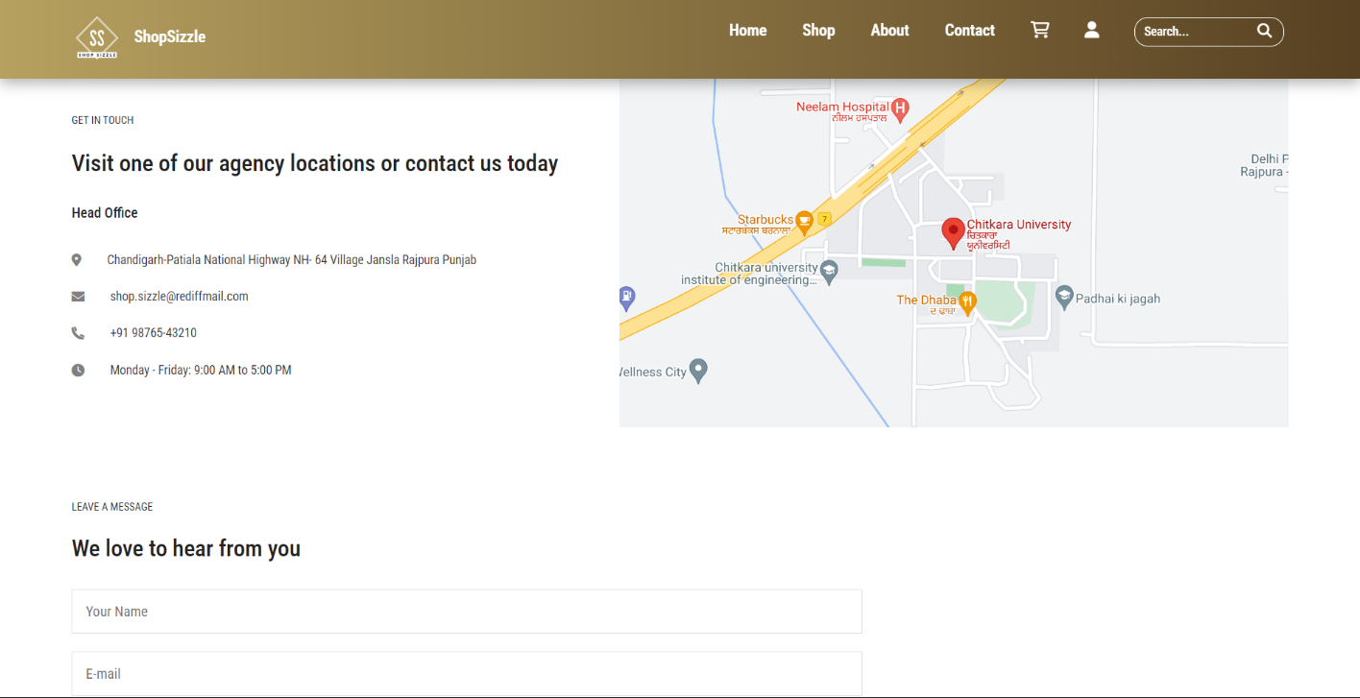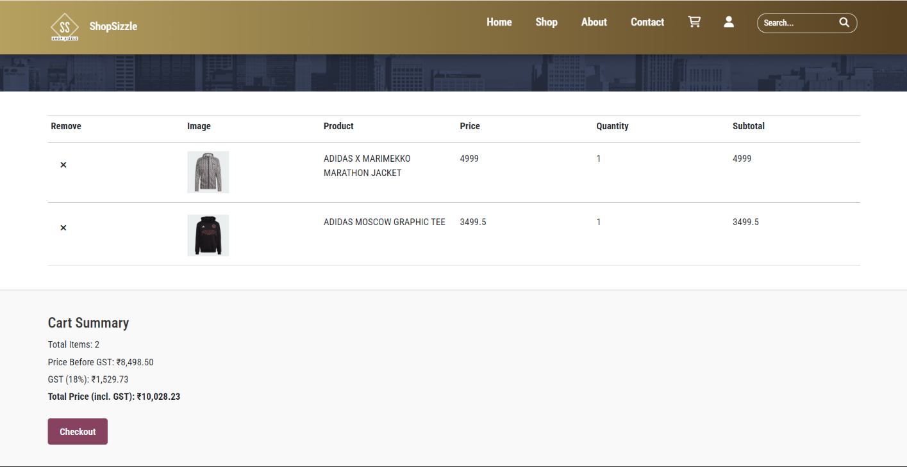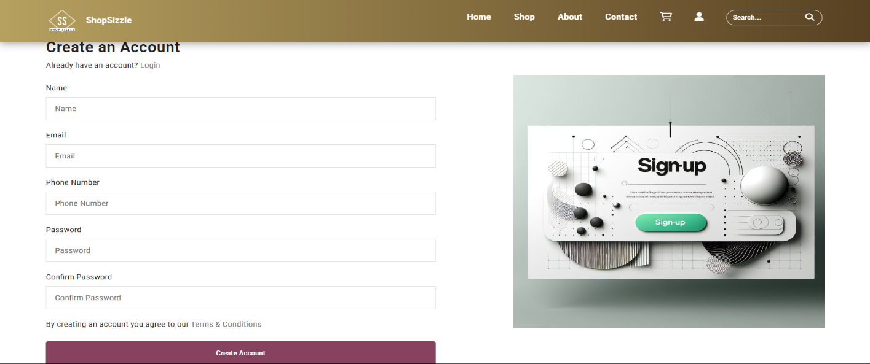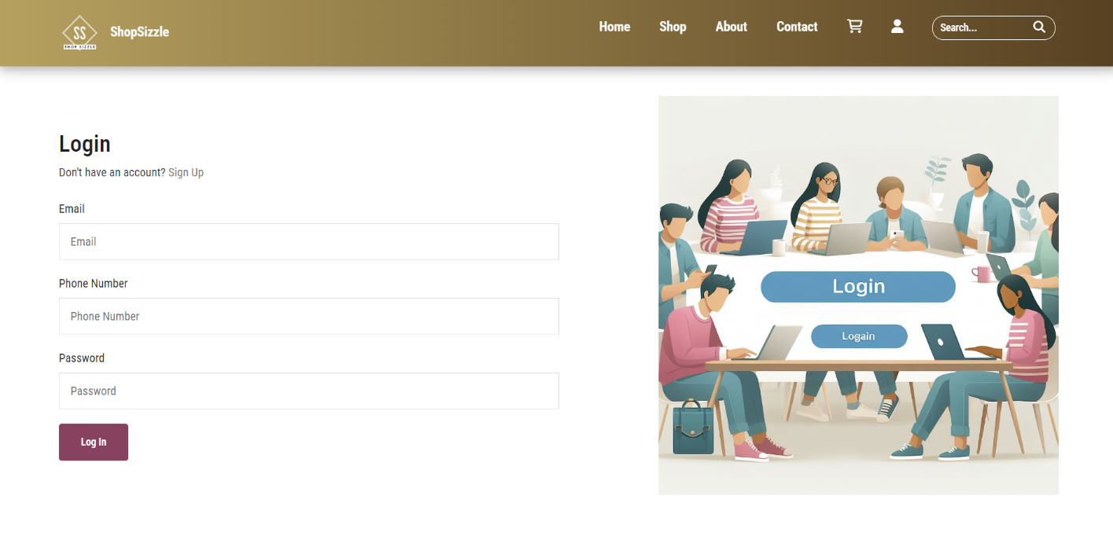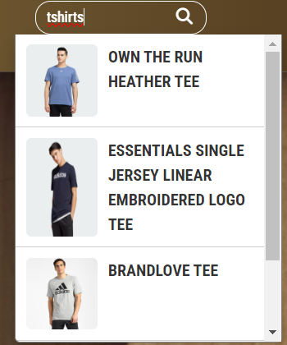

**References:**

* The products displayed are from **Adidas** and **Blackberry.**
* The banners used are used from **Peter England**, **Blackberry**.
* The access code is generated from **web3forms.com** for contact page.